Name : Alex Krauel  Address : 926 RT 028 RW 006, Desa Prenggan, Kecamatan Kotagede, Kota Yogyakarta, 55172  Mobile Number : 085246695024  E-mail Address : akrauel@princeton.edu |  | 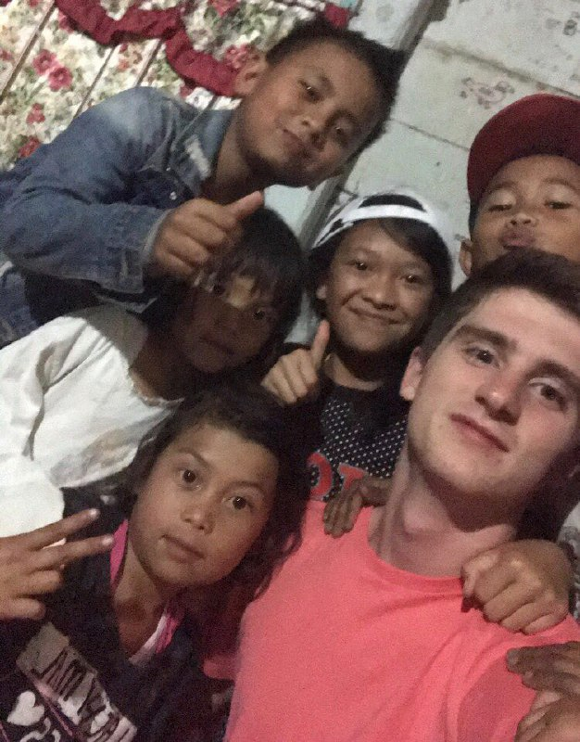
Personal Information
Date of Birth: October 19, 1999
Place of Birth: Princeton, New Jersey, USA
Sex: Male
Nationality: United States & Spain
Formal Education
- West Windsor- Plainsboro High School South (Princeton Junction, NJ)  - Thomas R. Grover Middle School (West Windsor, NJ)  - Village Upper Elementary School (West Windsor, NJ)  - Maurice Hawk Elementary School (Princeton Junction, NJ) |  |  | 2014-2018  2011-2014  2009-2011  2005-2009
Objective
To approach service learning effectively by making lasting friendships, memories, and connections at my NGO and learn more about local culture, values, lifestyle, and regional issues.
Experience & Activities
2014-2018 | Model United Nations Team, West Windsor NJ  President & Head Chair  - Managed over $10k in club finances, 5 overnight trips per year, and 150+ club members  - Coordinated committees, training sessions, sponsorship outreach, and correspondence for our school’s annual MUN conference of roughly 400 students
2015-2018 | Class President, West Windsor NJ  - Elected by my classmates in sophomore, junior, and senior years of high school  - Organized junior and senior prom, the senior trip, class fundraisers (talent shows, sports tournaments, football concessions), homecoming decorations, spirit week, class rallies, and picnics.
2016-2018 | Peer Leader, West Windsor NJ  - Selected by teachers and guidance counselor for leadership, personality, and attitude  - Led weekly peer groups with freshmen  - Coordinated school activities such as orientation, college fair and back to school night  - Fostered a positive and friendly school environment
2015-2018 | Science Bowl Team, West Windsor NJ  Team Captain  - Specialized in chemistry and energy sciences  - Placed 1st in NJ, and Top 12 in Nationals in 2017  - Organized biweekly practices, tryouts, invitationals, and mock competitions
June 2017 | American Legion Jersey Boys’ State  - Selected to represent my school at 1-week government simulation program for politically involved students across New Jersey  - Elected by my peers in the program to serve as State Senator, one of the highest legislative positions  - Co-drafted a bill about renewable energy expansion that passed in both houses of congress
July-August 2016  July-August 2018 | Student at French Immersion Programs  Alliance Française, Rouen, France  Institut Tourraine, Tours, France  - Stayed with local host family in France for 5 weeks as part of language and cultural immersion program (x2)  - Took classes and workshops about French language and culture for 35 hrs/week in the Alliance Française (2016) and Institut Tourraine (2018)  - Earned the DALF diploma for a C1 level of proficiency in French language
2014-2018 | WWP South Athletics  - Player on my high school’s varsity soccer and volleyball teams
2017-2018 | Independent Tutor  - Tutored 5 students in mathematics, chemistry, and biology throughout my senior year  - Prepared curriculum and materials for the one-on-one tutoring sessions
Community & Social Projects
2017-2018 | HITOPS, Teen Counselor  - Exposed teens in underserved communities to important topics about sexual health including STD prevention, healthy sex practices, homophobia reduction, and sexual assault awareness  - Led dozens of workshops and discussions in schools, community centers, and juvenile correction facilities across New Jersey  - 250+ volunteer hours at HiTOPS by the end of senior year
2015-2017 | American Cancer Society (Mercer County Branch), Vice President of Events  - Helped raise over $2,000/yr for the American Cancer Society to go towards cancer research and treatments  - Was lead coordinator of district-wide fundraisers such as Relay Idol, volleyball tournaments, local carnivals, and more
2015-2018 | Central Jersey Student Innovators’ Association, Co-Founder & Co-President  - Hosted seminars in science, technology, and innovation with professional guest speakers free of charge  - Coordinated outreach to potential speakers and event logistics  - Taught public speaking and presentational skills to interested teenagers
2014-2016 | West Windsor Soccer Association, Volunteer Coach  - Ran training and scrimmages for 4th and 5th grade recreational soccer players once a week
Strong Points
- Curious and open-minded, eager to readily escape comfort zone
- Very energetic and enthusiastic, especially when forming new ideas and connections
- Friendly demeanor and extroverted, love talking to everyone
- Not easily discouraged when dealing with setbacks, try to consider issues from different angles
- Skilled improviser, can deliver good quality results even with little time to prepare
- Light-hearted, know how to relax, and love to joke around and have fun!
Skills
Language Skills:
- English (native speaker)
- Spanish (native speaker)
- French (fluent)
- Bahasa Indonesia (sedikit-sedikit :) )

Computer Skills:
- Operating System: Windows & MacOS
- Application Program Office: Microsoft Office (Excel, Word, Power Point)

Other Skills:
- Public Speaking
- Event Planning
- Scientific Research
- Writing (investigative papers and summary reports)
- Cooking (and eating!)
- Good with children

Interests
Renewable Energy, Environmental Conservation, Education, Animal Welfare, Human Rights, Technology, Politics, Public Policy, Psychology, Mathematics, Philosophy

